**sequel dating**

June 25, 2018

Bryan Reznicek and Jeremy Cooley

|  |
| --- |
|  |
| Database Model (E-R Diagram) |
|  |
| Executive Summary |

Database Model (E-R Diagram)

Executive Summary

The database enclosed is to be used to set up an online dating/matchmaking website in a social media-type foundation. The social media layout will be utilized to bring more familiarity and fluidity to the user experience, while simultaneously allowing for easier implementation of data for the developers. The users’ preferences will be used to generate numerous queries on the database that will match users based on a finite number of factors such as education, occupation, whether they smoke, whether they drink, if they have kids, and if they are married, single, divorced, or complicated. The database may also be used on the developers’ end to generate reports to view data such as the profiles most recently updated, profiles in a particular location, or users in a certain age bracket. The database will also be implemented using MySQL utilizing the same design detailed in this summary.

The implementation of this database contains eight (8) tables that provide information about the ***Member, Profiles, Location, Pictures, Education, Occupation, Messages,*** and ***Privacy*** (Settings). These tables are the primary entities of the website and are used to define the relationships amongst the other entities. The ***Member*** table provides information about the user’s first name, last name, location, profile (ID), email address, date joined, and their gender. The ***Profiles*** table contains the associated member’s ID, profile picture (ID), date updated, distance seeking minimum, distance seeking maximum, education, occupation, smoker, drinker, number of kids, and relationship status. The ***Location*** table provides the city and state for the given location. The ***Pictures*** table provides information such as the title, description, filename, and upload date. The ***Education*** table contains information (if applicable) about a user’s educational background to include the high school name, high school location ID, high school graduation date, college name, college location ID, college start date, and college end date. The ***Occupation*** table contains information about the user’s work experience (if applicable) such as company name, company location ID, industry type, job title, date started, and date ended (if applicable). The ***Messages*** table contains information such as sender’s profile ID, recipient’s profile ID, date sent, subject, and message body. The ***Privacy*** table contains information about a profile’s privacy settings utilizing a level-scale ranging from 0-3 (OFF to HIGH).

The usage of this database greatly improves the ability to match users based on their entries to their profiles. For instance, a user may execute a search query in the website (or a developer running a search query utilizing the DBMS) to find *single* users of the opposite sex, in an age range, possess some college education, are currently employed, don’t smoke, but drink on social occasions because of the way the database will be implemented. The website will have as many options and preferences as deemed necessary to ensure the matchmaking algorithms will be maximized to their fullest potential, resulting in a satisfactory and, hopefully, life-long, partner.

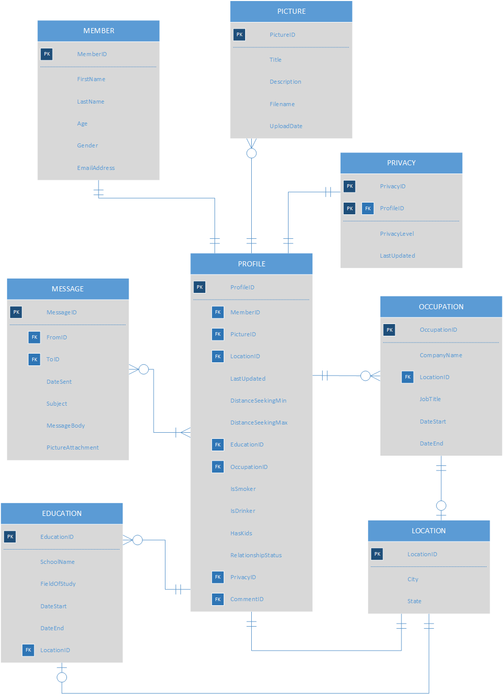Database Model (E-R Diagram)

The ***Member*** and ***Profile*** tables will have a one-to-one relationship as each member can have *one and only one* profile, likewise each profile can have *one and only one* member. The ***Profile*** and ***Picture*** tables will have a zero-to-many relationship as each profile can have *none or many* pictures, but each picture can belong to *one and only one* profile. The ***Profile*** and ***Privacy*** tables will have a one-to-one relationship as each profile can only have one privacy setting and *must* have privacy settings, and each privacy setting is unique to one and only one profile. The ***Profile*** and ***Occupation*** tables will have a zero-to-many relationship as each profile can have zero or more occupations, but each occupation can be associated with one and only one profile. The ***Profile*** and ***Location*** tables will share a one-to-many relationship as each profile must have one and only one location, and each location may be associated with zero or more profiles. The ***Profile*** and ***Education*** tables will share a one-to-many relationship due to each profile having zero or more educational levels, whereas each educational instance may be associated with one and only one profile. The ***Profile*** and ***Message*** tables will share a zero-to-many relationship because each profile may have zero or more messages, but each message belongs to at least one other profile, specifically at least (2) profiles. The ***Occupation*** and ***Education*** tables each share a zero-to-one relationship with the ***Location*** table due to each occupation or educational instance do not require a location to be associated with them but, if they do, may only have one location associated with that record, whereas each location may be associated with numerous occupations and educational instances.

Database Model (E-R Diagram)

Table and Query Implementation (Deliverable 3)

### Query 1

* <Fill in description of query1>

### Query 2

* <Fill in description of query2>

### Query 3

* <Fill in description of query3>

### Query 4

* <Fill in description of query4>

### Query 5

* <Fill in description of query5>

### Query 6

* <Fill in description of query6>

### Query 7

* <Fill in description of query7>